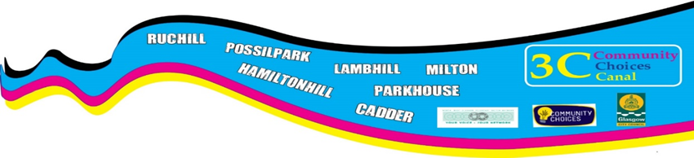

3 C Community Choices Canal Main fund Application form
We invite applications
up to £30,000

All applications have to be for the Economic Benefit of Canal ward
Please read guidance notes before you fill this out
fill out this application form and email to hello.northwestglasgowvsn@outlook.com
or post to Martina Johnston-Gray, NWGVSN, Yoker Resource Centre, 10 Kelso Pl; Glasgow. G14 0LL.
If you want help with filling it out email Rebeka or Lynn on hello.northwestglasgowvsn@outlook.com or call 0141 952 7090
Please fill this out before you complete the rest of the application.
Is your group constituted Yes No

Does your group have a bank
Account? Yes No
or
Do you have a partner organisation that can
Hold the funding for you, should your application Yes No
be successful at the voting stage?

(Please circle the answer that applies to you)

Section 1
Where you plan to deliver the project
Where will the project be delivered?
Please tick the neighbourhoods that your project will be delivered in.

Milton | Possilpark | Lambhill | Ruchill
Hamiltonhill | Cadder | Parkhouse | All of Canal ward

If your project benefits more than 1 neighbourhood and the percentage is not equal, please tell us the estimated percentage in each neighbourhood.
Milton % | Possilpark % | Lambhill % | Ruchill %
Hamiltonhill % | Cadder % | Parkhouse % | Canal ward %

Section 2
Your Contact information
Name of Group/Organisation

Address

Postcode

Contact person(who we can speak to about the application)

Telephone number

Email

Section 3

Which theme (s) does your project cover?

Please use this space to outline your proposal

Maximum 500 words

Section 4

Outcomes & impact
This is your chance to be more specific in what you want to do.
Please let us know what you expect to achieve over the next year.
Then please tell us what you are going to do to achieve your outcome.
Over the next year we will achieve:

To Achieve this we will do

Maximum of 200 words

Section 5

When will the project start and finish? (the money must be spent by March 31st 2020)

Section 6
Please give details of anyone you consulted about this project?

Section 7
Please let us know about any partners you will work with

Please outline the resources do you need e.g. how much money you want to apply for, for equipment, hall hire and so on.
Give a budget breakdown, how much you’re going to spend and what on

Section 8
 | Description | Amount
 | Total

Signed
Date

We will keep your data to process your application; we will need to share it with other parties (for example Glasgow city council) who are involved in the 3C Participatory Budgeting process. We will not share it with anyone else with out your express permission, by signing this you agree that we can keep your data for this purpose.
Please note deadline for applications is Friday March 29th at 5pm
Any application received after that date won’t be considered.
You or someone from your group/organisation must be available to attend the Community Choices Canal event on April 27th 11-3pm at Possilpoint Community Centre, where you will be asked to staff a stall and explain your idea to local people and how it will benefit the them.
People will then vote on who they want to fund, these votes will be counted and combined with the electronic votes and the organisations that have the most votes will receive funding.
You will be expected to submit an evaluation for your project, where we’ll ask you to tell us how you got on and anything you learned from doing it.

Thank you for your interest in 3C Community Choices Canal, we look forward to reading your application.

The 3C Community Choices Canal panel are:
- Ann Lawrance who lives is in Possilpark
- Sadie Gordon who lives in Westercommon
- Robert Stewart who lives in Possilpark
- Roy Greatorex who lives in Cadder and is a member of GDA
- Chris Kerr who lives in Milton
- Allan McGuiness who lives in Lambhill
- Lambert Iku who lives in Possiklpark and is also representing views of BME community
- Rose Sehakizinka who lives in Possilpark and is also representing views of BME community
The panel are supported by Martina Johnston-Gray from North West Glasgow Voluntary Sector Network who lives in Hamiltonhill

