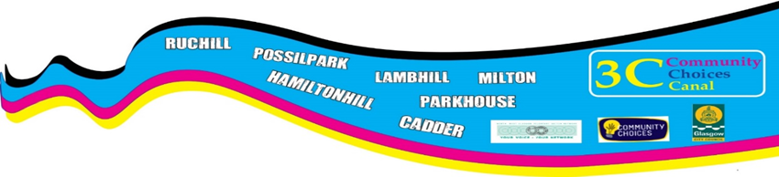

3 C Community Choices Canal Application form for the Try it out fund
We invite applications
£500-£1000

All applications have to be for the Economic Benefit of Canal ward
Please read guidance notes before you fill this out
Please fill out this application form and email to
hello.northwestglasgowvsn@outlook.com
or post to this address Martina Johnston-Gray, NWGVSN, Yoker Resource Centre, 10 Kelso Pl; Glasgow. G14 0LL.
If you want help with filling it out, email Rebeka or Lynn
hello.northwestglasgowvsn@outlook.com

who will be happy to help, or call 0141 952 7090
Please fill this out before you complete the rest of the application. Don’t be put off if you don’t have a bank account and constitution and/or don’t have an organisation who can support your application. We can help match you with an organisation who could be willing to support you. Call Martina on 0141 952 7090 or email martina.northwestglasgowvsn@outlook.com if you’d like help with this.
Is your group constituted Yes No

Does your group have a bank
Account? Yes No
or
Do you have a partner organisation that can
Hold the funding for you, should your application Yes No
be successful at the voting stage?

(Please circle the answer that applies to you)
Who can apply?
Project proposals are welcome from community groups or individuals who live and or work in the Canal ward.

Section 1
Where will the project be delivered?
Please tick the neighbourhoods that your project will be delivered in?

Milton | Possilpark | Lambhill | Ruchill
Hamiltonhill | Cadder | Parkhouse | All of Canal ward

Section 2 Your Contact information
Name of Group/Organisation

Address

Postcode

Contact person

Telephone number

Email

Section 3
Try it out fund

£500-£1000
Please tell us your idea or activity for Try it out to increase employability in Canal Ward.

Maximum of 300 words please

Please outline the resources do you need e.g. how much money you want to apply for, for equipment, hall hire and so on.
Give a budget breakdown, how much you’re going to spend and on what
Section 8
 | Description | Amount
 | Total

Signed
Date

We will keep your data to process your application; we will need to share it with other parties (for example Glasgow city council) who are involved in the 3C Participatory Budgeting process. We will not share it with anyone else with out your express permission, by signing this you agree that we can keep your data for this purpose.
Please note deadline for applications is Friday March 29th at 5pm
Any application received after that date won’t be considered.
You or someone from your group must be available to attend the Community Choices Canal event on April 27th 11-3pm at Possilpoint Community Centre, where you will be asked to explain your idea explain to local people and how it will benefit the them.
People will then vote on who they want to fund, these votes will be counted and combined with the electronic votes and the person or group that have the most votes will receive funding.
You will be expected to submit an evaluation for your project., where we’ll ask you to tell us how you got on and anything you learned from doing it.

The 3C Community Choices Canal panel are:
- Ann Lawrance who lives is in Possilpark
- Sadie Gordon who lives in Westercommon
- Robert Stewart who lives in Possilpark
- Roy Greatorex who lives in Cadder and is a member of GDA
- Chris Kerr who lives in Milton
- Allan McGuiness who lives in Lambhill
- Lambert Iku who lives in Possiklpark and is also representing views of BME community
- Rose Sehakizinka who lives in Possilpark and is also representing views of BME community
The panel are supported by Martina Johnston-Gray from North West Glasgow Voluntary Sector Network who lives in Hamiltonhill

