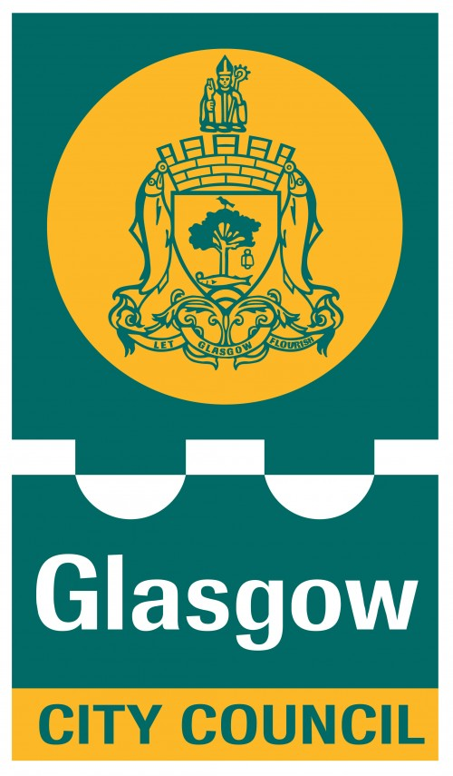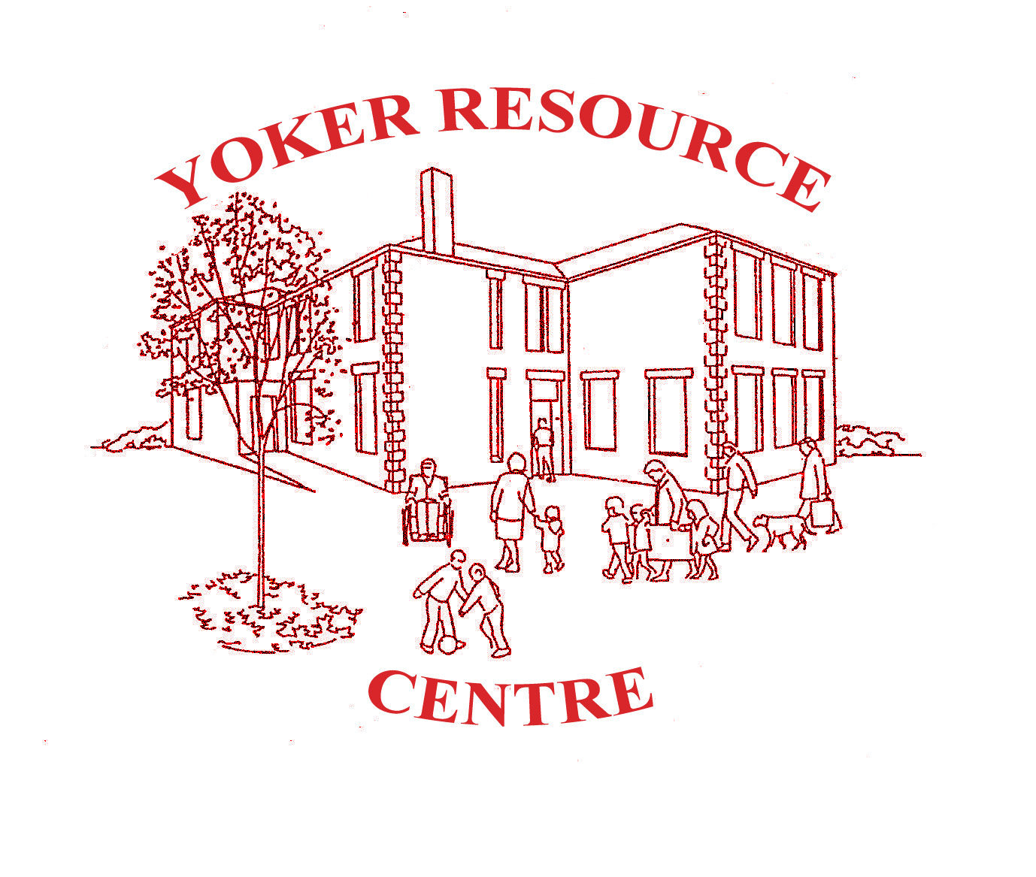

**YRC Registered Charity No. SC0 10367**

Supported by Glasgow City Council

**G13/G14**

**Community**

**Support Hub**

**Are you in need of support, advice or self-isolating due to the current emergency?**

**Contact us on 0141 952 6485**

**10am – 4pm Monday to Friday**

[**YokerCommunityAid@gmail.com**](mailto:YokerCommunityAid@gmail.com)

**Facebook: /YokerCommunityAid**

**Don't hesitate to get in touch and let us know how we can help.**

We have set up a community hub with the objective to give advice and support to all ages. If we cannot help you we will be able to signpost you to various other services/organisations with whom we are working in partnership with.

We have a number of volunteers throughout the G13/G14 area and are looking for further support from anyone else who wishes to put themselves forward.

We, and our partners could be able to offer you support, such as shopping, money/debt advice, physical or mental health support, referrals to the local foodbank, council services and much more. We are also keen to know what priority support you and the community can identify as a gap that needs addressed

If you are isolated or just in need of a conversation, we can also direct you to local support.