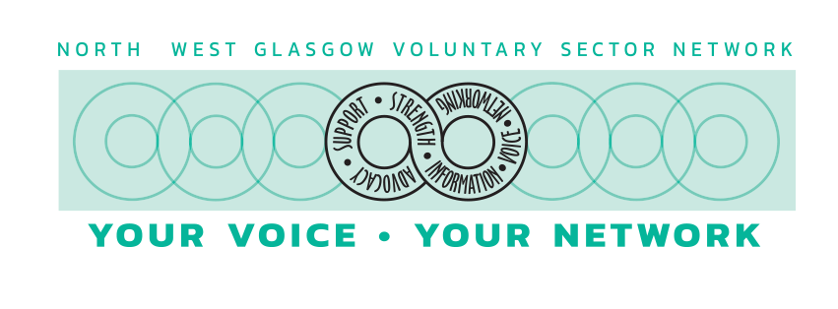
NORTH WEST GLASGOW VOLUNTARY SECTOR NETWORK

Job Application for development worker post

Name
Address
Phone number
email
National insurance number

If you are not a British passport holder or a European Citizen, or you do not have the permanent right to remain in the UK, you will require a work permit

Yes/No
Do you need a work permit to work in the UK?

If you already hold a work permit, when does it expire?

Education and Training

Subject | Level | Grade Achieved | Date
Continue a separate sheet if necessary

Please insert below any professional registrations currently held:

Employment experience: Current or most recent employment

Tile of post

Name and address of employer

Brief description of what organisation does

Date Started
Date ended (if applicable)

Please describe your current or most recent role

Previous employment history
Employer | Job Title | Started | Ended | Type of business
Continue a separate sheet if necessary

Supporting Information
Use the space below to match your skills and experience to the job description and person specification for the role. Please feel free to include any voluntary work or personal interests. Your experience outside work is just as valuable as experience you gain from paid employment.

References
Please give the names and contact details of two people as referees neither of which can be related to you. No approach will be made to your present employers before an offer of employment is made.

Equality Act 2010 – The North West Glasgow Voluntary Sector Network offers a guaranteed interview to any applicant who considers him/herself to be disabled and who meets the minimum essential requirements for the post.

Do you consider yourself to have a disability under the terms of the Equality Act 2010?

If Yes, please detail below any adjustments that you think we could make to support you in relation to the essential requirements of this job?

Please detail below any assistance/adaptations you require to help you attend, and participate in the interview if selected?

Declaration of interests

If you are related to any committee member, board member, or employee of any organization or project of the North-West Glasgow Voluntary Sector Network, pleased give details below or insert “not applicable”

Declaration

I certify that all statements given above by me on this form are true and correct to the best of my knowledge.

Signed
Date

Please return completed application form to
martina.northwestglasgowvsn@outlook.com
Closing Date for Applications: 9th September 2020
at 5pm.

