North West Glasgow Voluntary Sector Network
Tips for Re-opening Your Spaces
PLAN, PREPARE, PROTECT, REVIEW

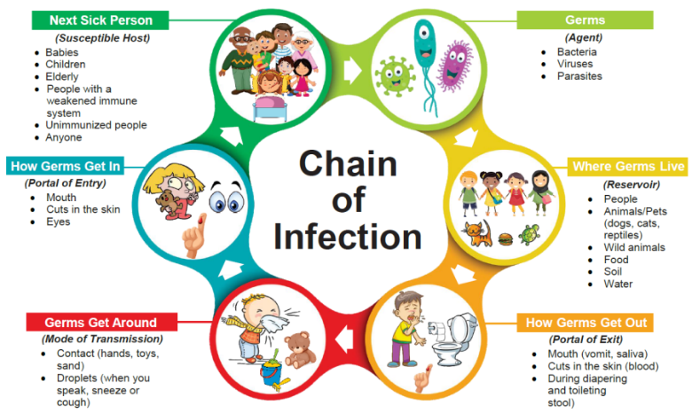
- Chain of Infection
Understand the chain of infection and how to break it
- The infectious agent
- The reservoir
- The portal of exit
- The mode of transmission
- The portal of entry
- The susceptible hosts
- How easily germs are transmitted video
- Hand hygiene video

- Reliable information
Use official and reliable sources of information
- Scottish Government https://www.gov.scot/coronavirus-covid-19/
- Health and Safety Executive https://www.hse.gov.uk/coronavirus/
- NHS Inform Scotland https://www.nhsinform.scot/
- World Health Organization https://www.who.int/coronavirus

- Risk assessment
You must:
- Identify what work activity or situations might cause transmission of the virus
- Think about who could be at risk
- Decide how likely it is that someone could be exposed
- Act to remove the activity or situation, or if this isn’t possible, control the risk
- Ensure if you are using a template that you tailor it to your organisation and activities
- Tenants should also do their own Risk Assessment

- Covid Outbreak Plan/Procedure
- What do you need to do if one of your staff or volunteers has symptoms?
- What do you need to do if there is a positive case on your premises and linked to your premises?

- Analyse Your Space and services
Analyse your spaces, services and people/groups who engage with you
- What space? Who uses the space? When do they use the space?
- What do they use the space for? Guidance will be different for different users & activities
- How can the Space be changed to adhere to Social Distancing?
- How can spaces be reconfigured or repurposed?
- See Spaces assessment matrix doc as an example on Google drive

- Identify High footfall areas and Contact Points
- Remove all unnecessary touchpoints
- Social Distancing: Establish One-way systems if needed/possible
- Cleaning rotas to link to high footfall/contact areas

- Stakeholders
Identify your different stakeholders and how you are going to engage with them
- Internal - staff, board, volunteers, trainees
- External – tenants, long term hires, groups, clubs, national bodies/associations.
- There may be guidance from national bodies eg karate, care commission for after school clubs etc...
- Some used a short online survey for staff/ volunteers or tenants to gauge their thoughts about re-opening

- Cleaning and Sanitising
Establish New Cleaning Schedules/Rota. Identify dedicated cleaning staff
- Internal or outsourced cleaning staff
- Sourcing PPE & cleaning materials for staff - masks, hand sanitisers etc
- Think about displaying cleaning records
- Set up sanitisation points at high traffic areas in the building (entrance, exit, loos etc)

- Signage and Social Distancing Adaptations
- Order Signage/Equipment - Consider signage that is generic in case government guidelines change (eg if Social Distancing changes from 2m to 1m)
- Look at links below for printable posters (NHS & FSB)
- Consider removable screens if needed
- Office desks side by side or diagonal are better than face to face

- Training / Induction Day/Walkthroughs
- For staff, cleaning team, tenants/clients etc - Explain changes and expectations
- PPE training
- Video walk-throughs posted online or sent to clients to explain all the safeguarding changes made in the building. Also to explain what you expect from them

- Phased re-opening
- Eg Staff, then volunteers, then selected groups
- This allows for staff to get used to changes and to review any issues
- Stagger staff days of work/start times
- Consider how best to collect/store contact details for Test & Protect

- Review & Keep-up-to-date
- Undertake regular reviews of everything – this may need to be a few times a day/week whilst you get settled, staff and users get used to the new routine/layout etc.
- The guidance and information relating to the coronavirus and how to manage it is being updated regularly.
- Review Procedures, Policies & Risk Regularly – KEEP CHECKING GOVERNMENT GUIDANCE

OH!!!.......And Start Planning for a Re-Lockdown NOW....

USEFUL LINKS
- Guidance for businesses for physical distancing which explicitly mentions community centres: "Businesses that must remain closed - non-residential institutions - community centres, youth centres and similar - unless for the purpose of hosting essential voluntary or public services, such as food banks, homeless services, and blood donation sessions."
- https://www.gov.scot/publications/coronavirus-covid-19-phase-3-business-and-physical-distancing-guidance/pages/businesses-and-premises-that-must-remain-closed/
- https://www.gov.scot/coronavirus-covid-19/
- New guidance published by Scottish Government for general spaces and buildings - https://www.gov.scot/publications/coronavirus-covid-19-general-guidance-for-safer-workplaces/
GUIDANCE RE OPENING SPACES/LEAVING LOCKDOWN
- ACAS Return to work Process map is very useful https://company-180825.frontify.com/d/9XEi1YzDsXxS/n-a#/general/return-to-the-workplace-process-map

- https://www.gov.uk/government/publications/covid-19-guidance-for-the-safe-use-of-multi-purpose-community-facilities/covid-19-guidance-for-the-safe-use-of-multi-purpose-community-facilities

- https://acre.org.uk/news/2020-06-17-practical-information-to-help-village-halls-reopen-published-by-leading-rural-charity

- https://www.hse.gov.uk/coronavirus/working-safely/covid-secure.htm

- https://scvo.org/support/running-your-organisation/leaving-lockdown

- EMBED: Inclusive Re-opening https://docs.google.com/spreadsheets/d/1O86HFa2M4lz9zqCvP3y9DelmXG7pul5k/edit#gid=1446856999

CHECKLISTS/PROCEDURES
- Good check list to work through and adaptable to Community Spaces https://www.gov.scot/publications/coronavirus-covid-19-tourism-and-hospitality-sector-guidance/
- Documents from Sports Scotland - easy to read and transferable to community Spaces
- https://sportscotland.org.uk/covid-19/getting-your-facilities-fit-for-sport/
- https://sportscotland.org.uk/media/5723/getting-your-facilites-fit-for-sport.pdf
- https://sportscotland.org.uk/covid-19/getting-your-facilities-fit-for-sport-resources/

POSTERS
- https://www.fsb.org.uk/resources-page/covid-19--a3-printable-signage-pack-.html

- https://www.nhsinform.scot/illnesses-and-conditions/infections-and-poisoning/coronavirus-covid-19/communications-toolkits-and-leaflets/coronavirus-covid-19-communications-toolkit
MISCELLANEOUS
- Considering going cashless? https://www.mobiletransaction.org/card-machine-small-business-uk/
- Funding - https://scvo.org/support/coronavirus/funding
ADDITIONAL RESOURCES
- Additional resources can be found on Google Drive SPACES File https://drive.google.com/drive/folders/1R11TCgx6x_OPQ__5COqib4fjm8iqXsU0

This document has been written by NWGVSN SPACES Working Group. This information and thoughts/suggestions have been gathered from the members of the working group based on their experiences
NWGVSN SPACES Working Group August 2020

Additional Information/background info the Group discussed

The group initially discussed what spaces were and listed Spaces below:
- Internal spaces
  - office space
  - activity/meeting spaces inc large halls
  - cooking/cafe spaces
  - internal publicly accessible spaces
  - entrances/exits
  - toilets
  - storage spaces and storage of 3rd party equipment
  - sub-let spaces
  - COVID19 emergency response spaces that need to transition back to other spaces
- External spaces (linked to building)
  - car parks
  - fire muster points
  - growing spaces - access to guidance from the Council allotment officer??
- Public spaces
  - immediate where people might queue etc
  - other public spaces
    - Council
    - Glasgow Life
    - Other providers
- Private spaces
- Use of third party spaces - hiring halls etc
  - e.g. Partick Burgh Halls, Church Halls, Community Centres#
- Virtual spaces

Impact of the loss of space due to Social Distancing
- Loss of service users - even if space is available some people won’t want to come back or unable to come back
- Loss of income
- Loss of staff/jobs
- Loss of service
- Re-designing services –eg move to online, telephone
- Repurposing spaces - cost of this

Space/User Analysis - Some questions for organisations to consider?
- What type of space do you have? ie office, activity, meeting, storage, outdoor, kitchen, cafe area, creche
- For each space
  - When is it used? Daily, a few times a week, once a week
  - What is it used for? Activity classes, sub-let to a tenant, storage
  - Who is it used by? In-house, 3rd party regular booking, 3rd party occasional booking
- Is the space usable in its current set up? Yes / Maybe / No / Don’t know
- Is the space able to be modified / adapted? Yes / Maybe / No / Don’t know
- If the space is not usable what type of space do you need?
  - Physical space
  - Virtual space
- What will the space be used for?
- What do 3rd party providers want from your space?
- Do they have guidance from a governing body/membership body?

What are the stakeholder groups that you need to think about?
- Board members
- Staff members - phased return, staff interviews, re-induction
  - some staff have been working
  - some staff have been furloughed - need to treat them differently
  - can’t have all staff back in at the same time
  - some staff will still be shielding
- People with disabilities
- Volunteers
- Trainees/Placements
- Service users (in-house)
- Service users (third party)
- Service providers/instructors
- Other centre users
- Centre visitors
- General public
- People who have been shielding - additional risks
- Contractors/workpeople

Example of short post lockdown client survey questionnaire
- Would you consider re-booking with the Whiteinch Centre after we re-open?
- If so, what days and times would you be interested in?
- Do you have any reservations about returning, and if so, what would you need us to do to remove them?
- Would you any have specific needs to successfully function in a social-distanced environment?
- Do you have any other issues you would like to raise at this time, or any comments you would like to make?

This document has been written by NWGVSN SPACES Working Group. This information and thoughts/suggestions have been gathered from the members of the working group based on their experiences
NWGVSN Spaces Working Group August 2020

North West Glasgow Voluntary Sector Network (NWGVSN) is a membership organisation representing Voluntary Sector organisations in the North West of Glasgow. If your charity, group or organisation is based in or offering services in the North West, you are eligible for Free Membership. https://nwgvsn.org.uk/membership-services/

~~End~~

