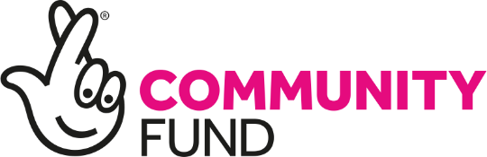

Glas-glow Up

Supporting young people in Glasgow

Application Form 2022
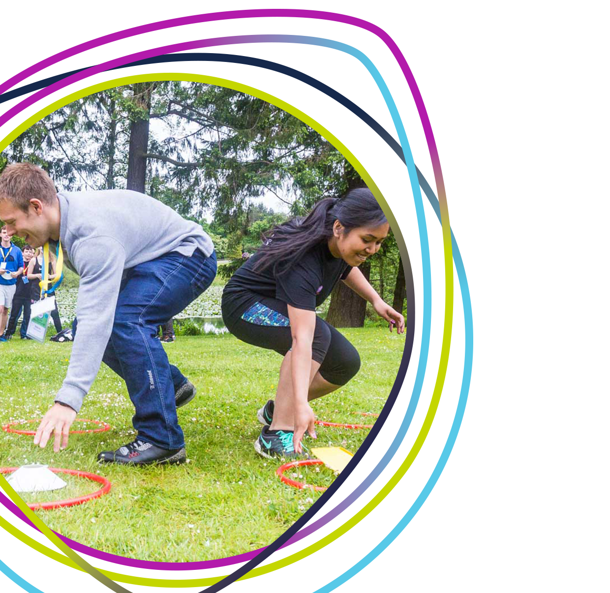
(including Terms and Conditions)

Before You Start
Please read the Guidance for Applicants before completing an application to Glas-glow Up to ensure you are eligible to apply. This funding is only available to groups based in specific areas of Glasgow.

Section 1 – Organisation Details

Name of Organisation:

Contact Name:

Position in Organisation:

Correspondence Address (incl. postcode):
Please be aware that this funding is only available to organisations in specific areas of Glasgow. Please read the Guidance for Applicants before applying.

If this is your personal address please place an X in this box

Preferred contact number:

Alternative contact number:

Email:

Local Authority:

Organisation’s website:

Postcode of the regular meeting place of your organization or project:
Scottish Charity Number (if applicable): |  | SC
*Youth Scotland Membership Number (if applicable): |  | 350_ _ _ _ _
Do you currently receive funding from Youth Scotland or The National Lottery Community Fund? (if yes please contact us before applying) |  | Yes / No
Annual income:  (please select one option which reflects your organisation’s most recent annual income e.g. 2020/21) | £0 - £9,999
 | £10,000 - £24,999
 | £25,000 - £49,999
 | £50,000 - £99,999
 | £100,000 - £200,000

*If you are not a member of Youth Scotland and would like to be, please find more information at www.youthscotland.org.uk/members/join.

For office use only:
Reference  Number | Grant  Requested | Grant  Awarded | Eligibility  Checked | Project  Report due | Report received

Section 2 – Tell us what you want the funding for and why?

Please tell us about your idea.
Approximately how many young people will benefit from this funding?
Age Group | Male | Female | Other | Totals
10 – 17
18 – 25
Totals

How does your project meet at least one of our funding priorities?
Glas-glow Up has five funding priorities:
- Provide safe spaces for young people to gather, take part in positive activities, and seek advice
- Support young people to get outdoors and become more active
- Engage young people who are not already involved with other services or youth programmes, for example through street work, outreach or drop in sessions
- Provide opportunities for young people to engage positively with other stakeholders in their communities, for example through intergenerational projects or youth led events
- Encourage young people to improve their local area, for example through litter picks
Is this activity new? | Yes / No

Please tell us how young people have been involved in planning this idea.
Please tell us when the project will start and finish
Start date |  | End date

Section 3 – Finances and Budgets

Expenditure | Estimated cost
e.g. Volunteer expenses
e.g. Venue hire
e.g. activity equipment
Total cost
Grant requested
If your activity costs more than £5000, please tell us how you are funding the balance and whether you have this funding confirmed.

Section 4 – Statement to be signed by applicant

Declaration
To the best of my knowledge, the information provided on this application gives a true and accurate account of this organisation’s work. I confirm that I am authorised to commit my organisation in this way. I confirm that I am authorised to sign that we will follow comply with the terms and conditions of this grant outlined below. I confirm that my organisation unconditionally authorises Youth Scotland to pass any details obtained about my organisation gathered in relation to this fund to our funders (see website for details) as supporters of this grants programme and relevant bodies involved in the decision-making process; to use such information as part of meeting Youth Scotland’s obligations to evaluate the impact of our work externally; and/or to use in promoting this programme through press or publications without the need to obtain any further consent or agreement from me or my organisation. Youth Scotland’s Privacy Policy details how we use, store and protects any personal data we manage through the provision of our programmes and membership services – please see www.youthscotlandorg.uk/privacy
I confirm that this application will enable our organisation to provide youth work opportunities for young people in our local community and I have read and agree to the Terms and Conditions set out on pages 8 - 9.
Signature: |  | Date:

Have you previously received a grant from Youth Scotland or The National Lottery Community Fund? | YES |  | NO
If yes, have you returned your End of Project Report form? | YES |  | NO
Please note that if you currently hold a grant from The National Lottery Community Fund you are still eligible to apply for this funding. However, the project that you are applying for must be different and separate from the one that is currently funded.

Answered all the questions on the application form? | YES
Application is signed in person by group leader? | YES
Included your latest annual income and expenditure accounts | YES
Included your most recent bank statement in the name of your organisation | YES

**Please read the Guidance for Applicants before completing this form. If you are unsure about any part of this form please get in touch to talk it through**

Terms and Conditions of our funding
- By submitting an application to Glas-glow Up funded by The National Lottery Community Fund and managed by Youth Scotland, the organisation named in the application (referred to as ‘you’ in these Terms and Conditions) agrees, if awarded a grant, to:
  - hold the grant on trust for The National Lottery Community Fund (referred to as ‘we’ or ‘us’) and use it only for your project as described in your application or otherwise agreed with us, and only for expenditure incurred after the date of the grant award;
  - provide us promptly with any information and reports we require about the project and its impact, both during and after the end of the project;
  - act lawfully in carrying out your project, in accordance with best practice and guidance from your regulators, and follow any guidelines issued by us about the project or use of the grant;
  - acknowledge The National Lottery Community Fund funding using the common lottery branding in accordance with the relevant brand guidelines and acknowledge Youth Scotland using Youth Scotland branding and social media handles;
  - hold the grant in a UK based bank or building society account which satisfies our requirements as set out in guidelines and requires at least two unconnected people to approve all transactions and withdrawals;
  - immediately return any part of the grant that is not used for your project or constitutes unlawful state aid;
  - where your project involves working with children, young people or vulnerable adults, adopt and implement an appropriate written safeguarding policy, obtain written consent from legal carers or guardians and carry out background checks for all employees, volunteers, trustees or contractors as required by law or our guidelines;
  - comply with data protection laws and obtain the consent of your beneficiaries for us and you to receive and process their personal information and contact them;
  - keep accurate and comprehensive records about your project both during the project and for seven years afterwards and provide us on request with copies of those records and evidence of expenditure of the grant, such as original receipts and bank statements;
  - allow us and/or the Comptroller and Auditor General reasonable access to your premises and systems to inspect project and grant records;
  - The National Lottery Community Fund publicising and sharing information about you and your project including your name and images of project activities. You hereby grant us a royalty free licence to reproduce and publish any project information you give us. You will let us know when you provide the information if you don’t have permission for us to use it in this way; and
- You acknowledge that we are entitled to suspend or terminate the grant and/or require you to repay all or any of the grant in any of the following situations. You must let us know if any of these situations have occurred or are likely to occur:
  - You use the grant in any way other than as approved by us or fail to comply with any of these Terms and Conditions.
  - You fail to make good progress with your project or are unlikely in our view to complete the project or achieve the objectives agreed with us.
  - You have match funding for the project withdrawn or receive duplicate funding for the same project costs as funded by the grant.
  - You provide us with false or misleading information either on application or after award of the grant, act dishonestly or are under investigation by us, a regulatory body or the police, or if we consider for any other reason that public funds are at risk or you do anything to bring us or The National Lottery Community Fund into disrepute.
  - You enter into, or in our view are likely to enter into, administration, liquidation, receivership, dissolution or, in Scotland, have your organisation’s estate sequestrated.

- You acknowledge that:
  - the grant is for your use only and we may require you to pay us a share of any proceeds from disposal of assets purchased or enhanced with the grant;
  - we will not increase the grant if you spend more than the agreed budget and we can only guarantee the grant as long as The National Lottery Community Fund continues to operate and we receive sufficient funds from it;
  - the grant is not consideration for any taxable supply for VAT purposes;
  - we have no liability for any costs or consequences incurred by you or third parties that arise directly or indirectly from the project, nor from non-payment or withdrawal of the grant, save to the extent required by law;
  - these Terms and Conditions will continue to apply for one year after the grant is paid or until the project has been completed, whichever is later. Clauses 1.2, 1.4, 1.6, 1.9, 1.10, 1.11 and 3.4 shall survive expiry of these Terms and Conditions; and
  - if the application and grant award are made electronically, the agreement between us shall be deemed to be in writing and your online acceptance of these Terms and Conditions shall be deemed to be a signature of that agreement.

In order to receive the grant, please sign the application forms agreeing to these terms and conditions and submit a copy of your most recent bank statement and accounts. You should return one completed application form to Youth Scotland by email at office@youthscotland.org.uk and keep a copy for your records.
The grant will be paid once your application has been reviewed and approved by the Funder following the deadline of 9.00am on Friday 11th March. We will contact you as soon as possible thereafter to advise you on the outcome of your application.
The grant will be paid by BACS transfer, as soon as possible once your application has been reviewed and approved for funding. Our aim is to review and confirm successful applications within six weeks of the application closing date.

This fund has been made possible through the generous support of our funder:

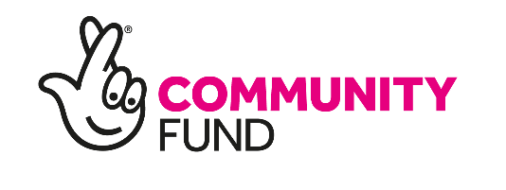

Youth Scotland: Balfour House, 19 Bonnington Grove, Edinburgh EH6 4BL
t: 0131 554 2561 ❙ f: 0131 454 3438 ❙ e: office@youthscotland.org.uk www.youthscotland.org.uk
A company limited by guarantee No: 125456. Scottish Charity No: SC000501. Registered in Scotland.

