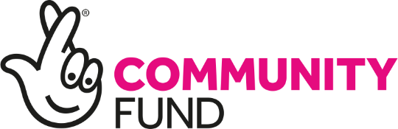
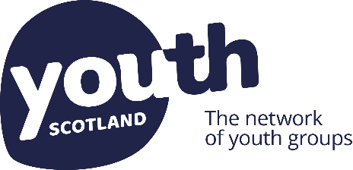

Glas-glow Up

Supporting Young People in Glasgow

Guidance for applicants
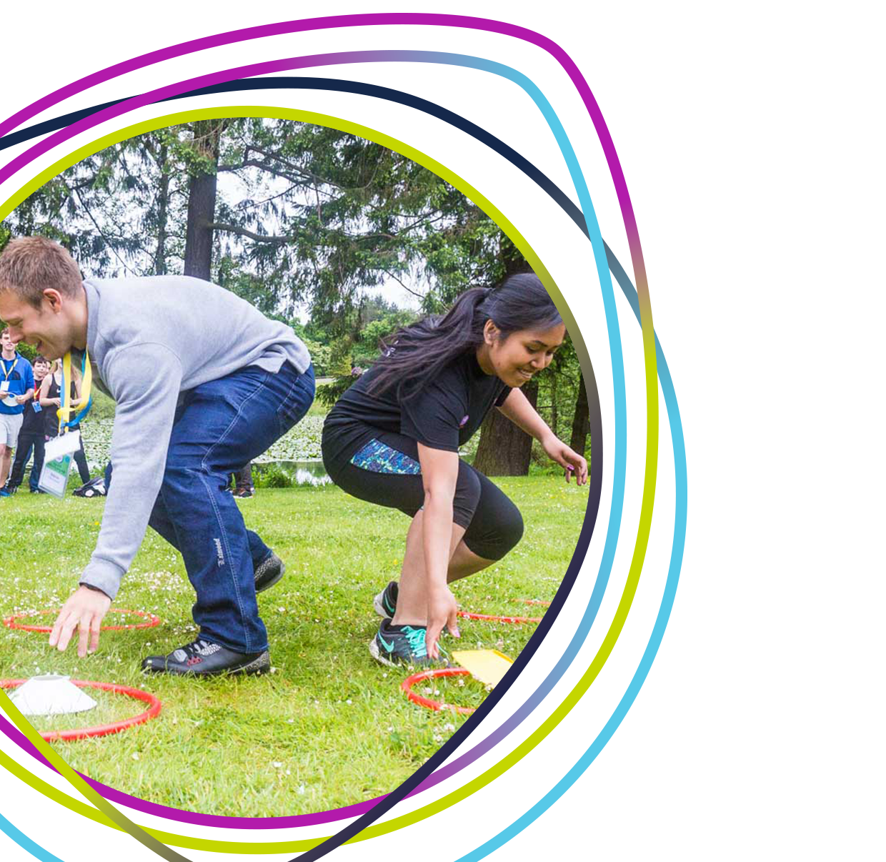

Guidance for applicants

What is Glas-glow Up?

The National Lottery Community Fund Scotland enlisted Youth Scotland to recruit and train a team of Young Grantmakers aged 13 - 25 from Bridgeton, Calton, Dalmarnock and Parkhead. They devised the priorities and application process for a small grants scheme that will distribute £40,000 by the end of March 2022 to projects that support young people in Glasgow. The aim of Glas-glow Up is to reduce anti-social behaviour and get young people involved in youth groups and programmes, in order to help young people to develop and inspire changes in their lives.

Glas-glow Up will support projects that:
- Improve one or more of the following areas in Glasgow (identified by the Young Grantmakers as areas affected by anti-social behaviour):
  - Bridgeton, Dalmarnock, Calton, Parkhead, Dennistoun, Camlachie, Shettleston, Tollcross, Baillieston, Mount Vernon, Provanhill, Possil Park, Barmulloch, Rob Royston, Milnbank, Rutherglen, Clydesdale, Muirhead, Garrowhill, Easterhouse, Garthamlock, Craigend, Cranhill, Riddrie, Hogganfield, Cardowan, Stepps, Milleston, Springburn, Glasgow City, Balornock, Milton, Ruchill, North Kelvin, Kelvinside, Partick, Govan, Craigton, Mosspack, Bellahouston, Govanhill, Pollokshields, Battlefield, Shawlands and Pollokshaws*
- Support young people aged 10 – 25 to develop and inspire changes in their lives
- Meet at least one of the funding priorities below

Our Funding Priorities
Glas-glow Up has five funding priorities:
- Provide safe spaces for young people to gather, take part in positive activities, and seek advice
- Support young people to get outdoors and become more active
- Engage young people who are not already involved with other services or youth programmes, for example through street work, outreach or drop in sessions
- Provide opportunities for young people to engage positively with other stakeholders in their communities, for example through intergenerational projects or youth led events
- Encourage young people to improve their local area, for example through litter picks

Who can apply?
This fund is open to organisations that meet all of the following criteria:
- Are either: a voluntary or community organisation; a registered charity; a constituted group or club; a not for profit company or a Community Interest Company
- Operate in one or more of the following areas of Glasgow and will run their project there:
  - Bridgeton, Dalmarnock, Calton, Parkhead, Dennistoun, Camlachie, Shettleston, Tollcross, Baillieston, Mount Vernon, Provanhill, Possil Park, Barmulloch, Rob Royston, Milnbank, Rutherglen, Clydesdale, Muirhead, Garrowhill, Easterhouse, Garthamlock, Craigend, Cranhill, Riddrie, Hogganfield, Cardowan, Stepps, Milleston, Springburn, Glasgow City, Balornock, Milton, Ruchill, North Kelvin, Kelvinside, Partick, Govan, Craigton, Mosspack, Bellahouston, Govanhill, Pollokshields, Battlefield, Shawlands and Pollokshaws*
- Plan to run a project with young people aged 10 – 25
- Have a turnover of less than £200,000
- Plan to spend the grant within 6 – 9 months of receiving it
- Can evidence that young people have been involved in the development of the project idea
- Have a UK bank account or building society in the legal name of your organisation, with at least two unrelated people who are able to manage the account.
Please note that if you currently hold a grant from The National Lottery Community Fund you are still eligible to apply for this funding. However, the project that you are applying for must be different and separate from the one that is currently funded.
You do not have to be a Youth Scotland member group to apply for this funding. If you would like to become a Youth Scotland member, more information can be found at www.youthscotland.org.uk/members/join
*Map of eligible area below:

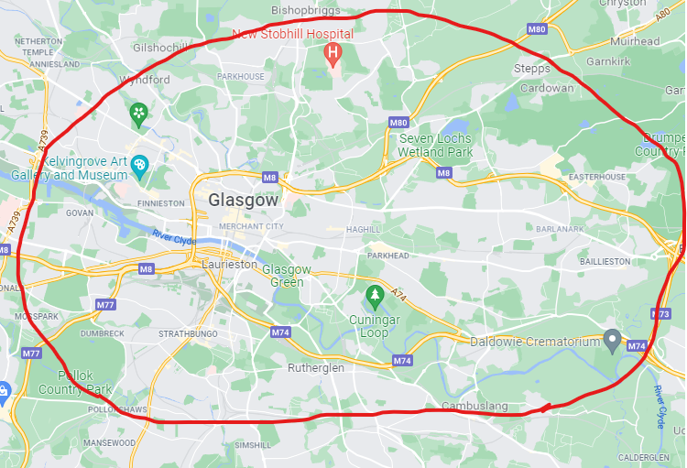

How much and what can I apply for?
Groups can apply for grants worth £2000 - £5000. See the table below for what we can and can’t fund:
We can fund: | We can’t fund:
- Equipment  - One-off events  - Staff costs  - Training costs  - Transport  - Utilities/running costs  - Volunteer expenses.  - We encourage you to think about any organisational costs needed to help you and your community through the COVID-19 crisis. | - Alcohol  - Contingency costs, loans, endowments or interest  - Land or building projects  - Activities that take place during school hours (this does not include after school projects)  - Electricity generation and feed-in tariff payments  - Political or religious activities  - Profit-making/fundraising activities  - VAT you can reclaim  - Statutory activities  - Overseas travel  - Activities that primarily benefit one individual or a closed group of individuals

How and when do I apply?
Please complete our application form and email it to office@youthscotland.org.uk. The deadline for applications is 11th March 2022.
If you have any questions, would like to discuss your idea before applying or have challenges completing the application form then please get in touch. We want to help. You can contact us either by calling 0131 554 2561 or emailing the address above.

What happens after I apply?
The team of Young Grantmakers will review all applications after the deadline and decide how to allocate the available funding. We aim to let you know the whether you have been successful within 6 weeks of the deadline.
